Chemistry internship at EMBL
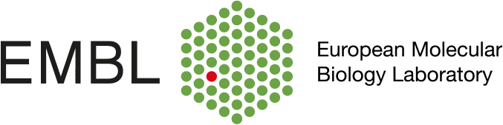
Carsten Schultz’s group at the European Molecular Biology Laboratory (Heidelberg) is looking for a Master student with a strong background in organic chemistry, to join the team as soon as possible for a 3 to 6 month internship. The Schultz group is interested in developing chemical biology tools for imaging and manipulating cellular processes. The student will be involved in a collaborative project with Cellzome, a GSK company, on the development of novel chemical probes for understanding drug mode of action and target engagement in cells. If you are interested, please contact Dr. Cécile Echalier at cecile.echalier@embl.de

